Bermuda Dunes Community Center • 78-400 Ave 42, Bermuda Dunes

GUIDED MEDITATION
HYBRID PROGRAM – OnLine & inperson

Class includes basic stretching, review of meditation steps, and guided meditation session. No experience necessary
WHO: | Individuals with a special need or disability  8 Years of Age and Over
WHEN: | Ongoing, Fridays 4:15 - 5 P.M.
FEE: | $25 per month, or FREE with our  ADAPTIVE MEMBERSHIP
EXTRAS: | If joining us online through , the class information will be on your receipt after registering for the ONLINE class.  - Best Location: A comfortable spot, i.e., bed, couch, pillow fort, chair.  - Wear comfortable clothing  - Water

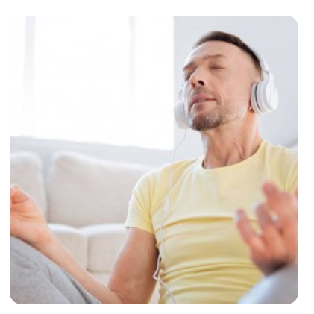
Sign up using either the IN PERSON or ONLINE option!

